**Unusual competitions**

**Have you ever done anything crazy? Did you get an award for it? No? Well, here might be something for you – crazy contests.**

[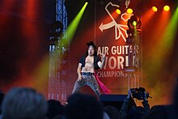](http://en.wikipedia.org/wiki/File:Airguitar_WC2010_1.JPG)**Air guitar playing**

Air Guitar World Championships started in Finland in 1996. In this contest, each participant pretends to play the guitar on stage. There are 1__________________ of one minute each. In the first round, the contestants choose their own song. In the second round, they have to play a song that the organizer chooses. Usually the song remains a secret until the round begins, so the contestants have to improvise. All constants have to play alone. Besides the technique and the artistic look of playing an 2_____________________, the judges give points for how well the contestant can rock the house.

Photo: Anitagraser / Wikipedia

**Wife carrying**

[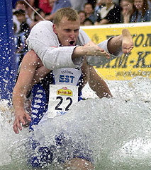](http://upload.wikimedia.org/wikipedia/commons/7/78/Estonian_Carry_style.jpg)Wife-carrying competitions also come from Finland. In this sport, male competitors carry a 3_____________________ through a special track (usually across sand, grass and water) as fast as possible. The women must be at least 17 years old and must weigh at least 49 kilograms. The men can use the 4_____________________: piggyback, fireman’s carry (over the shoulder), or Estonian-style (the wife hangs upside-down with her legs around the husband’s shoulders, holding onto his waist). The winning couple get the woman’s weight in beer.

Photo: Steve Jurvetson / Wikimedia Commons

**Pancake racing**

[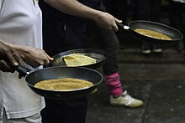](http://en.wikipedia.org/wiki/File:Pancake_race_London_on_your_marks.jpg)On Pancake Day, pancake races are held all over the UK. The contestants, traditionally women, race to the 5____________________ with a frying pan in their hands and at the same time toss the pancakes into the air. The winner is the first who crosses the line and manages to toss the pancake a certain number of times. Men can participate too, but they have to dress up as housewives (usually in an apron and a bandanna). They say that the tradition originated in the town of Olney when one housewife was so busy making pancakes that she forgot the time. When she heard the church bells ringing for the service, she ran to church with her 6__________________ and pancake still in her hand.

Photo: Pedro Figueiredo / Wikimedia Commons

**Mobile phone throwing**

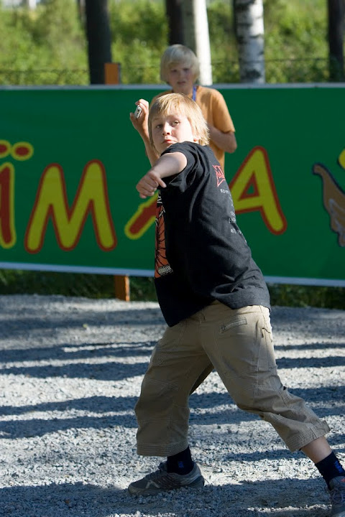Mobile phone throwing is another competition that started in Finland. The participants throw mobile phones and get points for distance or technique. There are officially two categories: Traditional and Freestyle. In the first category, the contestants throw the phone over their shoulder. The 7__________________ wins. In the second category, contestants get points for how beautiful and creative their throws are. Many mobile phone throwing events are supported by mobile phone 8__________________ and promote the recycling of mobile phones.

Photo: courtesy of Savonlinnafestivals.com